Farm Business Resilience Planning Assistance Sheet
Purpose of this document is to assist in completing the Farm Business Resilience Plan for Horticulture. It is presented, following the headings in the Horticulture Farm Business Resilience Plan template, as provided in HORT 360 Best Management Practice platform. http://www.Hort360.com.au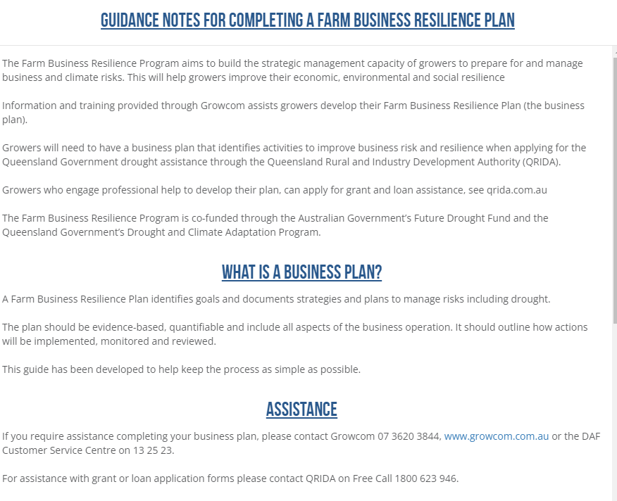

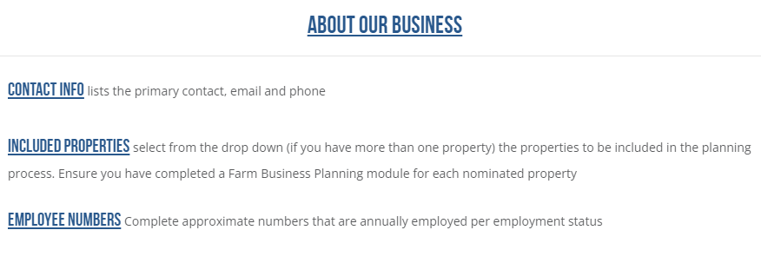

Motivation
Motivation must include your long-term view. Include why you are farming, your goal, and objectives.
Eg: In 5 years’ time… (Include a sentence to describe production, resources, the business and personal goals). Include your current situation changes you have seen and changes you wish to implement
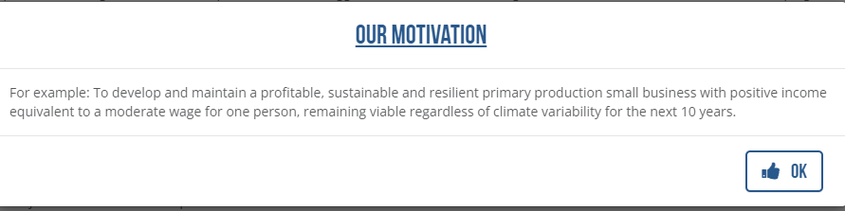

Drought Management
This section is designed for you to consider your current situation and how you currently prepare, manage and recover from drought. It should provide a ‘snapshot’ of current situation. It can then be drawn from directly when communicating how the new actions and associated investment will improve this situation. Include methods and strategies you apply to prepare, manage and recover.

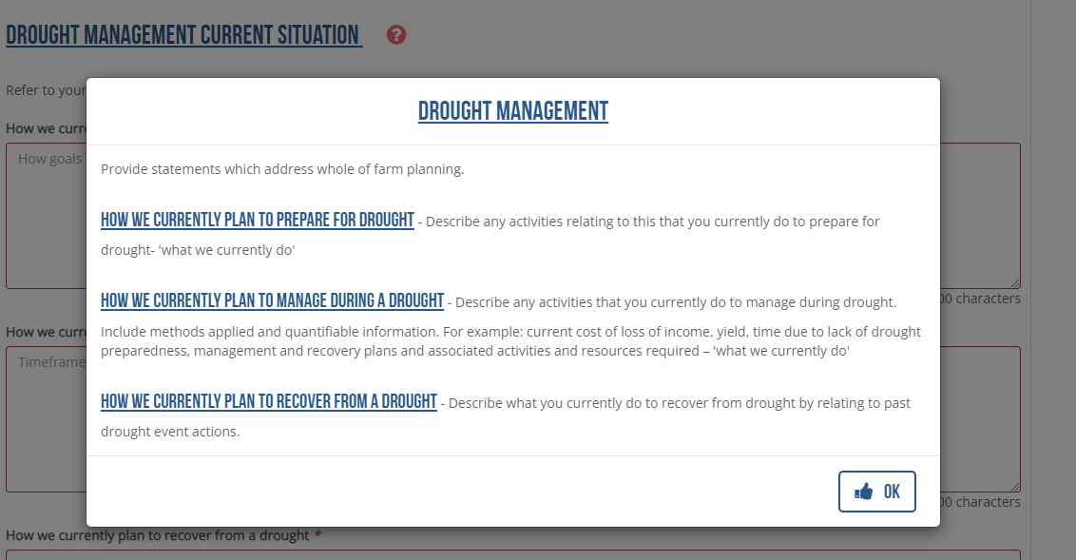

For example:

How we currently prepare for drought.

- Ensure you have the maximum available water on hand to best complete your seasons cropping
- Maintain your ground to best possible producing condition coming into a drought
- Have the best efficient cropping cycle coming into a drought
- Mulch crops

How we currently manage during drought.

- Reduced cropping area
- Maintain ground cover
- Water efficient crops
- Mulch crops

How we currently plan to recover from a drought

Methods and strategies you use to recover from a drought.
- Improve soil health.
- Mulch/green mulch to activate soil biome.
- Cropping methods to best rejuvenate soils /crops.
- Use lessons learned to be prepared for next drought
.

Management Areas

The farm business resilience plan shows how you have considered all aspects of your farm business. Each management area guides you to consider your current management situation, goals, risks pertaining to that management area, your plans to mitigate those risks and what outcomes you expect from taking that action. Include identifiable triggers, for example soil moisture/soil test results, determination of fertilizer use, crop condition, fruit condition, yield.

In the Monitoring and Evaluation section, the purpose is to check your progress and measure change to improve management. All outcomes must be measurable and linked to risk, and associated strategies and actions.

Examples from HORT360 provided over page.

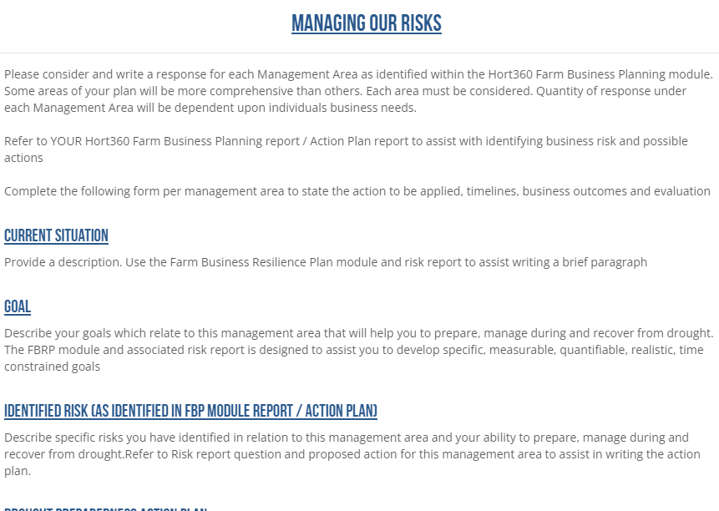

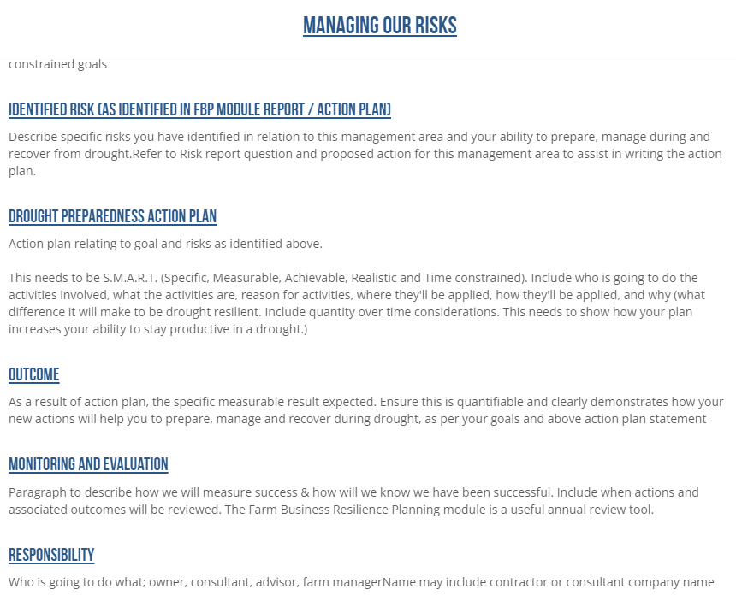

You will see that there are tabs for each management area, including:
- About Us
- Our people
- Our infrastructure
- Hort Ops
- Business
- Caring for land

Goals
When you write your goals and action plan, be as specific as you can, particularly with regard to the area you are seeking funding support.
Eg:
In 5 years time our production will be…,
this will be achieved through…
Goals should be S.M.A.R.T (Specific, Measurable, Realistic, Time framed)
These are listed in each of the management areas of your whole business, guiding you to consider all aspects of your business. For example:

Production Goals

How our production goals will be achieved
Explain how your goals will be achieved over the next 5 years. What do you have planned to have achieved?

Timeframe
Year 1 –
Year 2 -
Year 3 -
Year 4 -
Year 5 -
(List your goals over the 5 years)

How we measure success
How will you know if you’re on track? Write it down. Final statement that wraps the above up…

Risks
List all the risks you’ve identified, including what you have control over and what you don’t. Often business plans include a S.W.O.T (Strengths, Weaknesses, Opportunities & Threats). Strengths and Weaknesses are often what you have control or influence over. Opportunities and Threats are often external. Meaning, you have no control over whether they occur or influence, but you recognize that they will impact your business. Eg: Drought – you have no control over it, but you can manage for it.
S.W.O.T. helps to identify risks, risks are weaknesses and threats and impact your business resilience.
Separate Risks into the areas, as identified in the checklist questions of the Farm Business Resilience Planning Module (each of the component areas). These are the sections shown on the risk report. The risk report provides a guide, you can copy and paste directly from it into the plan and add further information. The Module and the Risk Report are resources to assist you to complete all the necessary areas of the Farm Business Resilience Plan. The ‘Our Risks’ section relates mostly to the insurance risks, governance etc.
Use the drop down menu in the HORT 360 Farm Business Resilience Module to answer each of the questions below for each component of your business.

Identified Risk
What is the risk? State what it is.

How will your planned action to mitigate / reduce the risk be achieved?
What are you going to do about it?

Timeframe
When are you going to do it?

Assignee
Who’s job is it to carry out the solution / who’s involved?

How the outcome improves our business to be more drought resilient
What difference will this planned action make? How will it make you more resilient over the longer term and better able to prepare for drought and other threats? Not all the areas will relate to drought resilience, it may be that the action plan is to continue what you’re doing or the action plan has nothing to do with drought.

Evaluation
How will you know if your plan worked. What will be the result? Include a detailed monitoring and evaluation process for the strategies applied.

Resilience Statement
Your Resilience Statement needs to be specific.
This is what you plan to do to make you resilient and will apply the funding support to achieve the difference.

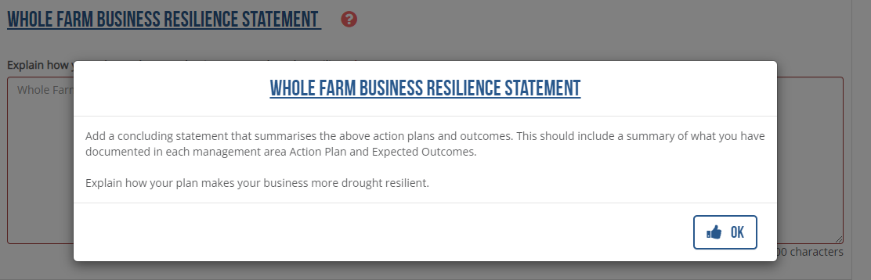

Include:

Current Situation: What are your trigger points for change?

Eg: hectares involved, megalitres applied, current yield short falls, why you need to make the changes.

What are the changes you intend to make, provide exact details, provide quantities, specifications & area / crop applied. (Trigger points)

Provide the value of what the difference will be.

Eg: Additional megalitres, additional yield the developments will make, increased $ or percentage return.

Explain why this plan will make you more resilient. (Refer to trigger points).

Detailed monitoring and evaluation process for the strategies applied.

